**Smartinternz Externship**

**Data Analytics with IBM Cognos Analytics**



**The Cognos HR Scorecard**

**Assignment - 2**

Name: MOUNIKA SATYA PRASEEDA KALLAKURI

Email ID: [praseeda.21bce9173@vitapstudent.ac.in](mailto:praseeda.21bce9173@vitapstudent.ac.in)

Registration Number: 21BCE9173

**AIM: Measuring Success in Talent Management**

**Challenge**: - Upload the dataset to Cognos Analytics, prepare the data, explore and Create Interactive Dashboard, Report and Story.

For the given dataset, the following changes have been made in order to remove noisy and unwanted data. Some attributes appear to be potentially unnecessary due to their similarity or redundancy.

MaritalStatusID and MaritalDesc: These two attributes seem to represent the same information, marital status, in different ways. Thus for this project we will be removing MaritalstatusID.

RaceDesc: This attribute is unnecessary. It's not entirely clear what it represents or if it's needed for the analysis.

PositionID: If the Position attribute already contains the text name/title of the person's position, PositionID might be redundant .

**Exploring the dataset and visualizing .**

1. **Dateofhire coloured by position sized by termd**

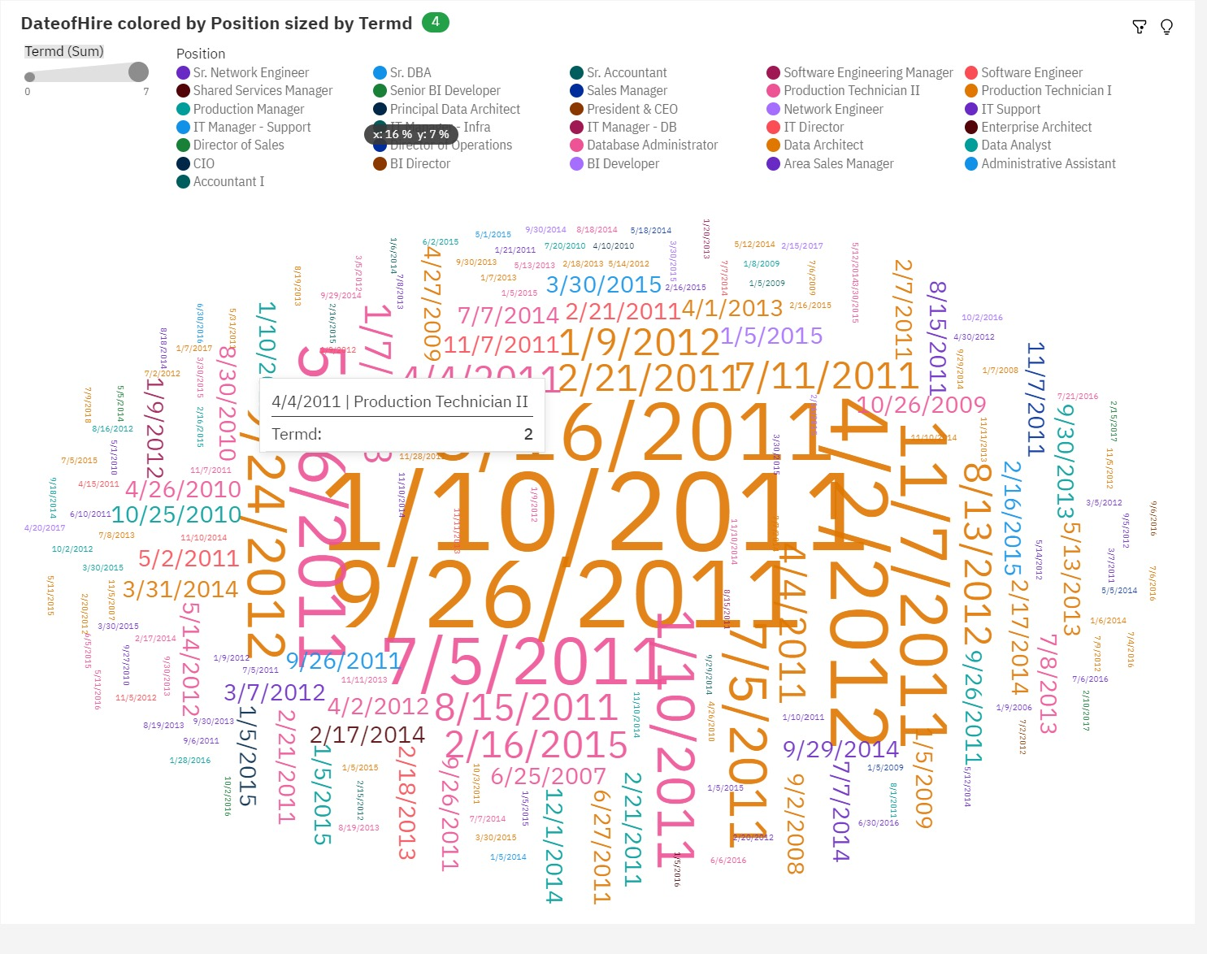

**2.Salary by Performance Score and Department.**

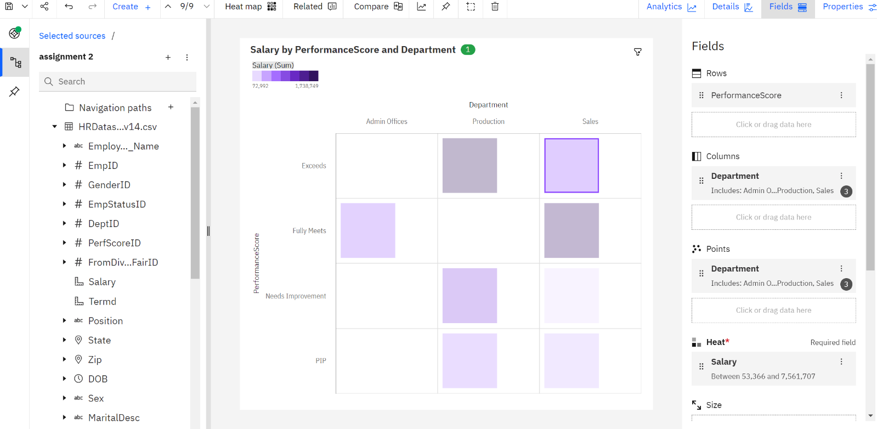

**3.Department and Salary for Performance Score colored by Department**

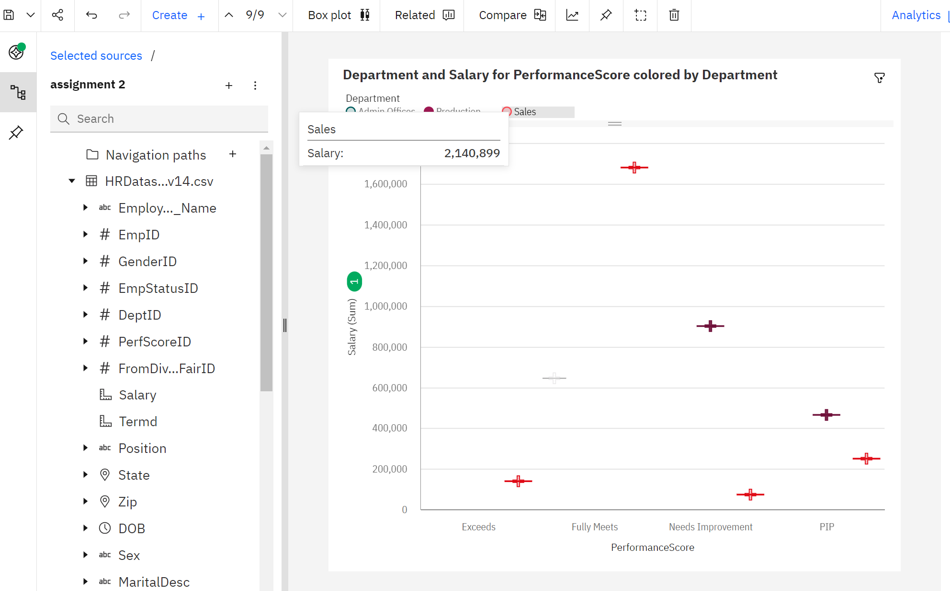

**4. Salary by Position**

.

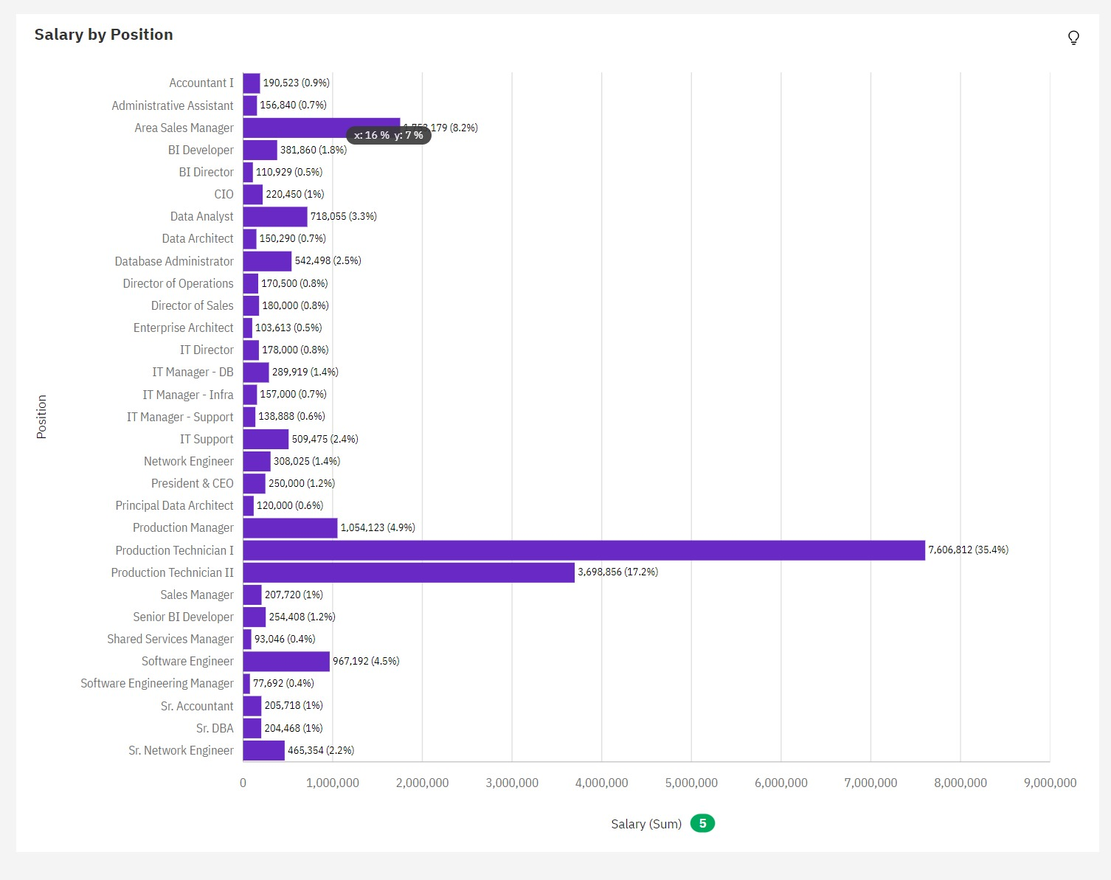

**Creating a Dashboard On HR Scorecard.**

From the created dashboard, we can derive the following insights:

On January 5, 2009, employees with the DateofHire had the highest Salary, exceeding 316 thousand dollars. Among them, employees with Manager ID 2 contributed the most, with a combined salary of nearly 171 thousand dollars.

Regarding Salary, the DateofHire with the most significant impact is January 5, 2009, with cumulative Salary values exceeding 316 thousand dollars, representing approximately 23.9% of the total

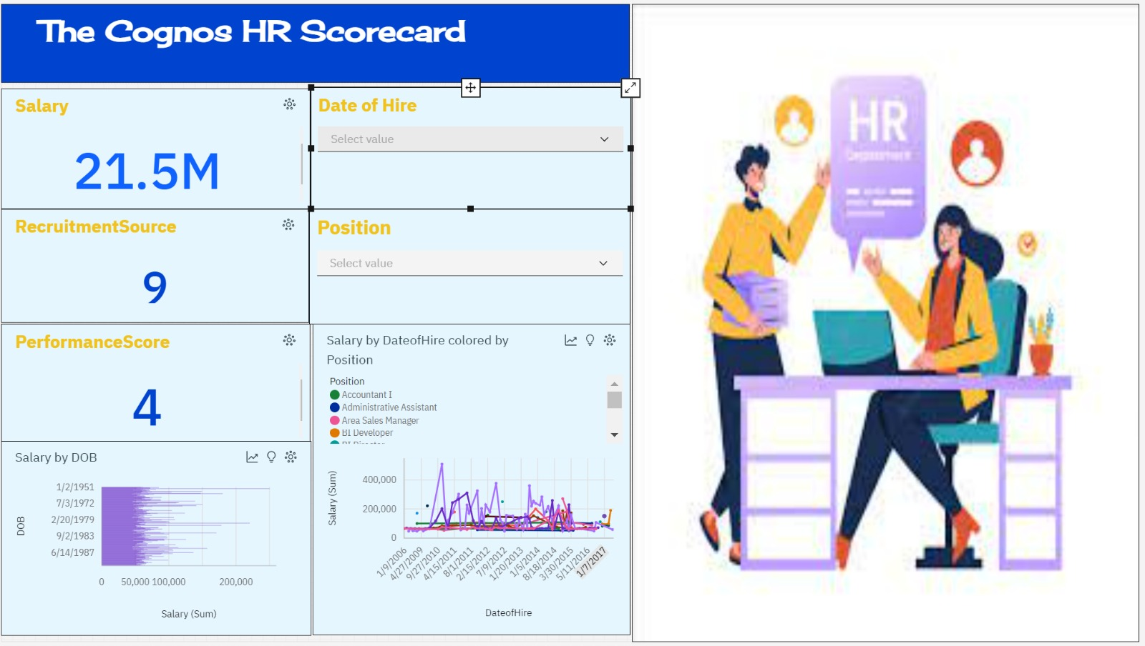

Creating a dashboard based on visualizations obtained from the dataset.

When considering all DateofHire values, the total sum of Salary amounts to over 1.3 million dollars.

The aggregated Salary values vary, ranging from over 47 thousand dollars to over 316 thousand dollars.

**Creating a Report**

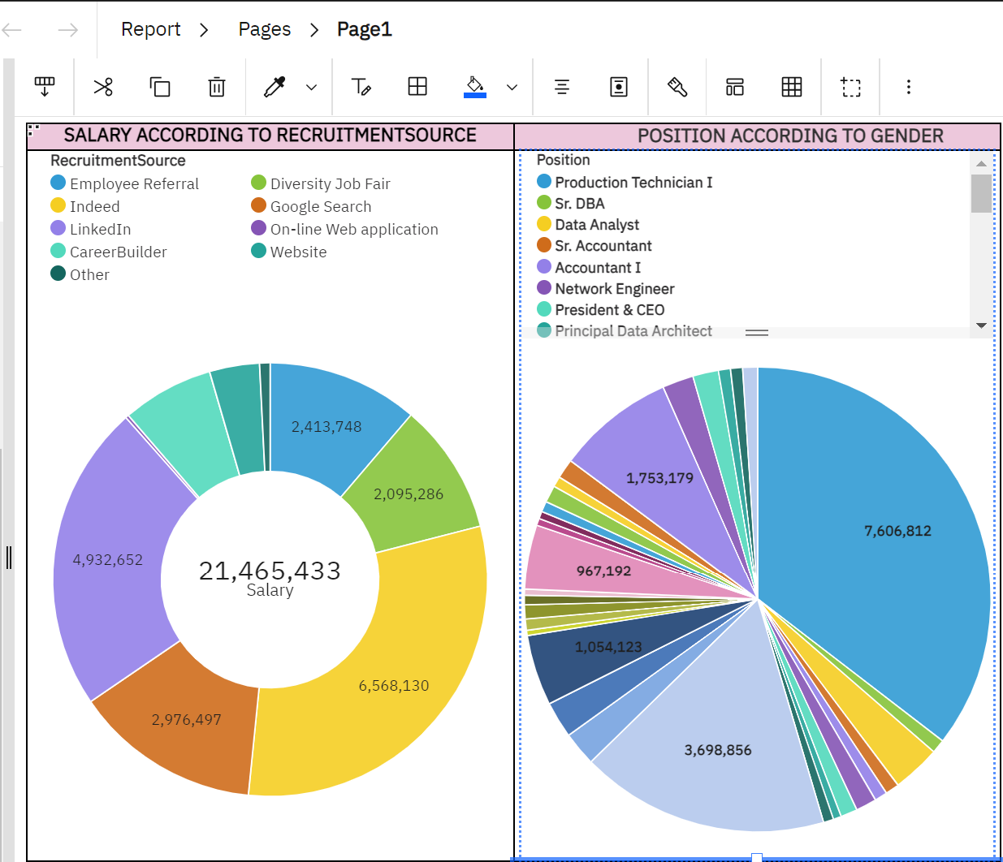

**Creating a Story**

